# WSA6 – Workshop Guide: Deep Dive: Developing Data Visualization Case Studies in Global Health Using Jupyter Notebook

**Date:** August 20, Monday, 1:00-5:00 PM

**Session Description** (500 words / 4000 characters including spaces)

In 2016, the World Health Organization recognized Thailand as one of the first two countries that eliminated maternal to child transmission of HIV/AIDS. Jupyter Notebooks (<http://ww.jupyter.org>) is an open source application that enables the creation of interactive documents containing software code (e.g., Python, R, Julia) and rich text and multimedia elements (e.g., video, images, web links, embedded documents). During this workshop, we will demonstrate how to the use of Jupyter Notebooks, for reproducible data science by developing a digital case study on the 1854 Cholera epidemic in London, UK. The workshop participants will divide themselves into groups and work on designing and developing the 1854 John Snow Cholera Outbreak digital case study using Jupyter Notebook. The trainees will then manipulate data, write some Python code and develop the prose, code and visualizations (including an interactive map, using Jupyter Notebook. To complete the workshop, the trainees will test and package the notebook.

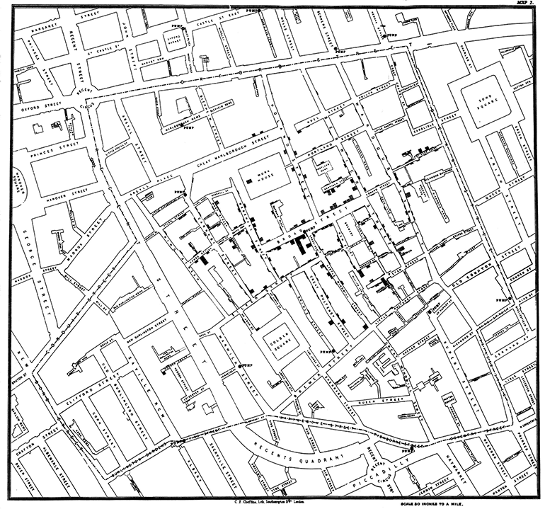

*Figure 1. Map of showing cholera deaths, London, 1854*

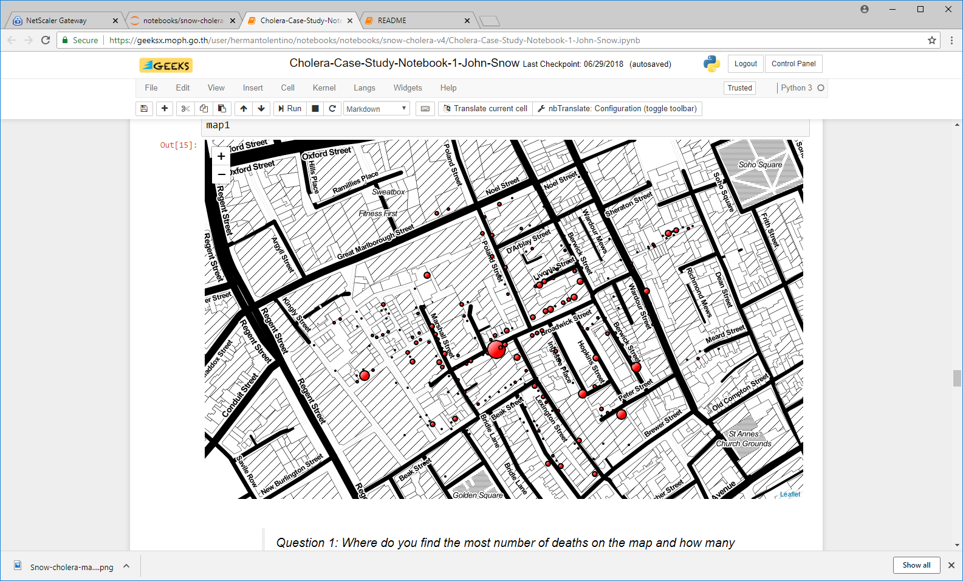

*Figure 2. Rendering of map in Figure 1 using data on cholera deaths in London, 1854, and interactive Python Folium web mapping package*

**Learning Objectives**

(At the conclusion of this session, attendees will:)

1. Recall the steps in setting up a Jupyter Notebook server for implementing a digital case study for data visualization
2. Apply key concepts in data visualization to the development of a digital case study
3. Working in small groups, design and test a digital case study
4. Package a digital case study for distribution

**Pre-workshop Instructions**

1. Register for a GitHub account to use the digital case studies on the Thailand Ministry of Public Health Jupyter Notebook Server. Test your userid and password (log in to GitHub) and send your working GitHub userid to [jmacgregor@cdc.gov](mailto:jmacgregor@cdc.gov). You will receive a confirmation email that your Jupyter Notebook account has been created on the server below (#3).
2. Download the latest session guide (this document) and other readings from this [link](https://centersfordiseasecontrol.sharefile.com/d-sa415437c811431eb).
3. Log in to the Jupyter Notebook Server (<https://geeksx.moph.go.th>) and practice launching the Jupyter Notebooks for the case study:
   1. Launch and read the “HelloWorld.ipynb” notebook from your home folder.
   2. Go to the “shared” folder (click on the link) and launch the “PHI-Conference-2018” notebook.
   3. Run all cells as instructed then go to your “notebooks” folder and into the “PHI-Conference-2018” subfolder.
   4. Launch the “README.ipynb” notebook for initial instructions.
4. Bring your own WiFi-enabled laptop or tablet, with the latest Chrome, Firefox or Safari browser, to use for the workshop (Internet Explorer does not work well with Jupyter Notebook). Practice launching <https://geeksx.moph.go.th> from your device.

**Session Schedule**

| **Time** | **Activity / Learning Objective** | **Speaker / Moderators / Facilitators** |
| --- | --- | --- |
| 1:00 – 1:10 PM | Workshop quick check registration and laptop set up |  |
| 1:10 – 1:15 PM | Introduction to Jupyter Notebooks, Setting Up your own Jupyter Notebooks Server, Housekeeping (15 minutes) | Speaker: Herman Tolentino |
| 1:15 – 1:25 PM | Brief Introduction to the John Snow Cholera Outbreak (10 minutes) | Moderator: Supharerk Thawillarp |
| 1:25 – 1:35 PM | Key Concepts in Data Analytics and Visualization (10 minutes) | Speaker: Zhanar Haimovich |
| 1:35 – 1:45 PM | Organizing Your New Notebook: Outlining Your Case Narrative with MarkDown Text (10 minutes) | Speaker: Jan MacGregor |
| 1:45 – 2:00 PM | Organizing Your New Notebook: Creating Layers of Code and Data in Your Notebook, Using Design Thinking – 10 minutes | Speaker: Jim Tobias |
| 2:00 – 3:00 PM | Instructions (10 minutes)  Group Work (50 minutes) | Moderator: Yakubu Owolabi  Facilitators: Jim Tobias, Xiaopeng Qi, Zhanar Haimovich, Pai Thawillarp, Jan MacGregor, Lisa Murie |
| 3:00 – 3:15 PM | Break / Q&A with Workshop Team / Continue Work (15 minutes) |  |
| 3:15 – 3:45 PM | Present Case Study and Receive Feedback – Volunteer Group (30 minutes) | Moderator: Yakubu Owolabi  Facilitators: Jim Tobias, Xiaopeng Qi, Zhanar Haimovich |
| 3:45 – 4:00 PM | Improve Case Study (15 minutes) | Moderator: Xiaopeng Qi  Q&A Panel: Jim Tobias, Zhanar Haimovich, Pai Thawillarp, Jan MacGregor |
| 4:00 – 4:30 PM | Present Case Study and Receive Feedback – Volunteer Group (30 minutes) | Moderator: Yakubu Owolabi  Facilitators: Jim Tobias, Xiaopeng Qi, Zhanar Haimovich |
| 4:30 – 4:45 PM | Case Study Packaging / Download Zip File (15 minutes) | Herman Tolentino |
| 4:45 – 5:00 PM | Summary and Next Steps / Evaluation | Herman Tolentino, Yakubu Owolabi |